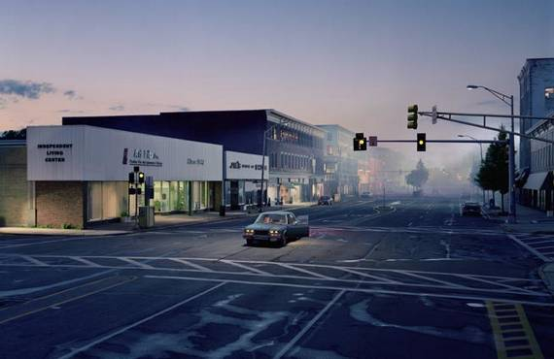
Gregory Crewdson
2004
Lonely
eerie
surreal
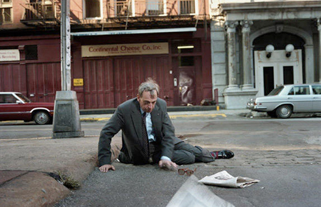
Philip Lorca DiCorcia
1980
Sad
Helpless
Weak
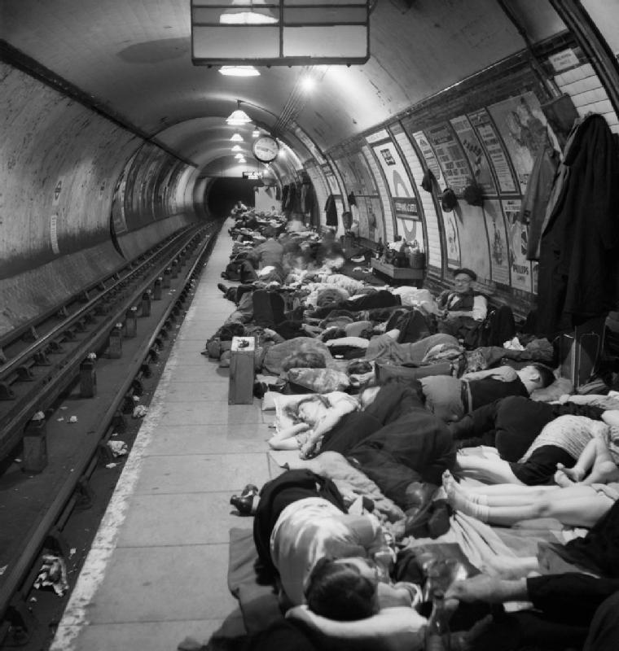

Bill Brandt
1940
Grave
Depressing
Desolate

Adjective photos

The first photo by Gregory Crewdson has a lonely tone to it. It also has an eerie feeling to it. There is one car on the road and one of its doors is open. It appears that no one is in the car. The car is in the middle of an intersection. There is nobody in sight. This creates the eerie feeling. It is also lonely because of the one lone car on the road. I think the photographer was trying to evoke a lonely feeling in the viewer

The second photo by Philip Lorca DiCorcia has a sad helpless feeling. The poor man is lying on the ground and he looks very helpless. His glasses are off to the side and he looks hurt. No one else is around to help him up which makes it sad. He looks weak and it appears that he needs help. The fact that he is alone makes it very sad

The third photo is by Bill Brandt. It is a photo of people sleeping in a subway. It is depressing because it appears that these people are homeless. They almost look dead which creates an eerie feeling. The black and white makes the photo seem old which puts it into a time perspective. They are all sleeping together which shows unity and togetherness. Although it is sad you can see hope in this photo.

